ONE PAGE BIODATA

Name of Teaching Staff | Prof. Mali Gayatri Dattatray |  |  | 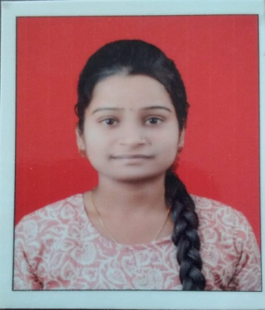
Date of Birth | 06/11/2002
Designation | Technical Assistant
Department | CSE
Date of Joining the Institution | 12/03/2025
Caste | OBC
Qualification With Class / Grade | UG | PG |  | Ph.D.*
Qualification With Class / Grade | B.Sc  1st class Distinction | MCS  1st class Distinction
Total Experience in Years | Teaching | Industry |  | Research
Total Experience in Years | 1Years | -- |  | --
Paper Published | National | 00 | International |  | 00
Paper Presented in Conferences | National | 00 | International |  | 00
Ph.D. Guide? Give Field& University | Field |  | University
Ph.D/Projects Guided | Ph.D. |  | Projects at Masters Level |  | 0
Books Published/ IPRs / Patents
Professional membership | -
Consultancy Activities | Nil
Awards | Nil
Grants Fetched | Nil
Interaction with Professional Institutions | Nil

